

Long Beach
Community Improvement League
2222 Olive Avenue

Long Beach CA 90806

Press Release
November 15, 2004

Re: Las Brisas Child Care Center, a Gift of the S. Mark Taper Foundation
2399 California Avenue, Signal Hill, California 90755
Opening Ceremony, Thursday, December 9th, 3:30 p.m.

Dear Member Of Press,

The Long Beach Community Improvement League (CIL) and the Los Angeles Community Design Center (LACDC) cordially invite you to the opening ceremony for the Las Brisas Child Care Center, a Gift of the S. Mark Taper Foundation.

This new, state-of-the-art facility provides high quality and affordable licensed child development and family services to over 140 preschool and school age children and their families in the Signal Hill and Long Beach Communities. The center was designed and built by the LACDC as part of a $20.8 million neighborhood revitalization project, which also includes 96-units of affordable housing, a new community center, and a new public park. CIL, the operator for this facility, has over 40 years history of offering a myriad of services to the community and is a pioneer in providing quality child care.

State, county, and city of Long Beach and Signal Hill elected public officials, community leaders, residents, and our friends and supporters have been invited to join CIL & LACDC board of directors, staff, and families at this opening ceremony scheduled for Thursday, December 9 at 3:30 pm. A brief ceremony will start promptly at that time. A reception including refreshments and entertainment will immediately follow. There will also be a tribute to the following funders for their generous contributions to this community project:

S. Mark Taper Foundation
Weingart Foundation
The Ahmanson Foundation
Ralph M. Parsons Foundation

For more information and confirm attendance please call or email Laura Sidney (562) 951-3500, lsidney@lbcil.org, or check our website: www.lbcil.org

Sincerely,

Farah Naz Khaleghi, Ph.D,
Executive Director, Long Beach Community Improvement League

Ali Barar,
Acting Executive Director, Los Angeles Community Design Center

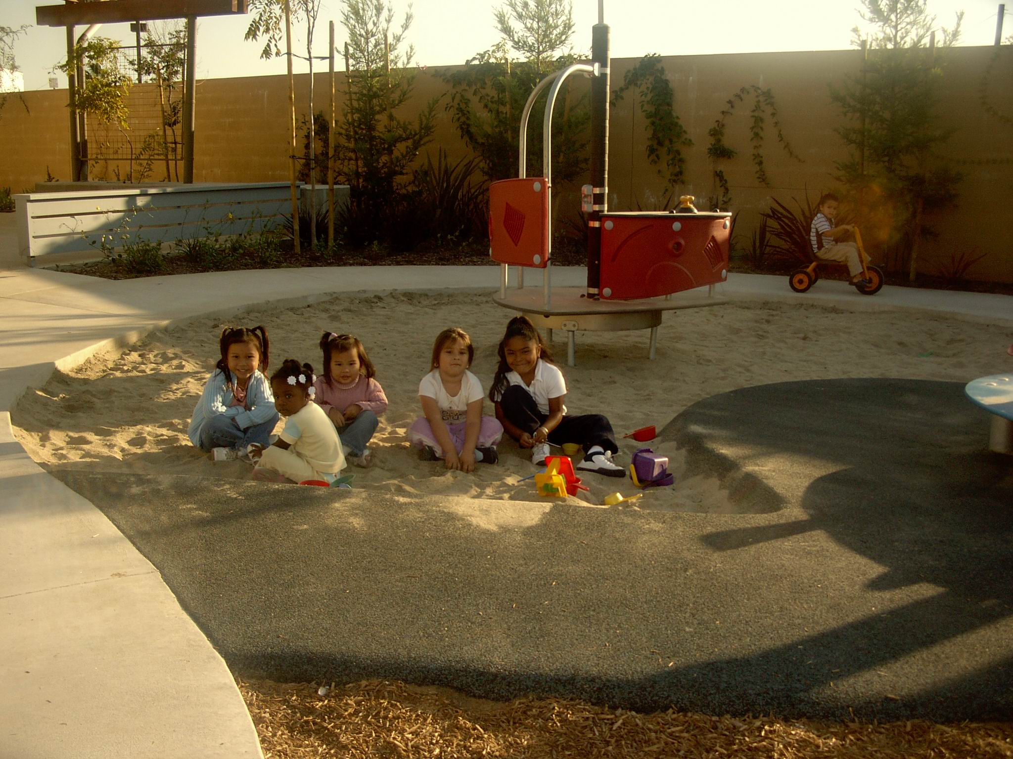

Opening Ceremony, Thursday
December 9th, 2004
3:30 PM

2399 California Avenue
Signal Hill, CA 90577
Tel: 562.989.5766

CIL & LACDC
